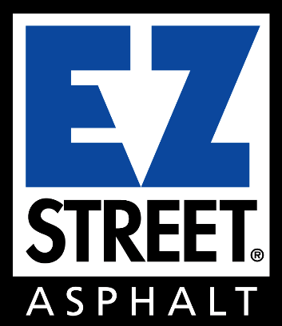

Thank you
for your loyal support of
EZ Street products.

Now that traffic volumes are light and crews are at a minimum, now is a great time to patch a few potholes. Practicing social distancing and accomplishing goals at the same time! Stay safe, if you don’t feel good don’t go into work. We will all get through this together!

Team EZ Street

